AI ASSISTED CODING
ASSINGENMENT-6
NAME:K.POORNACHANDER
HALL.NUMBER:2403A52382
BATCH:AI 14
Task Description #1:
• Start a Python class named Student with attributes name, roll_number, and marks. Prompt GitHub Copilot to complete methods for displaying details and checking if marks are above average.

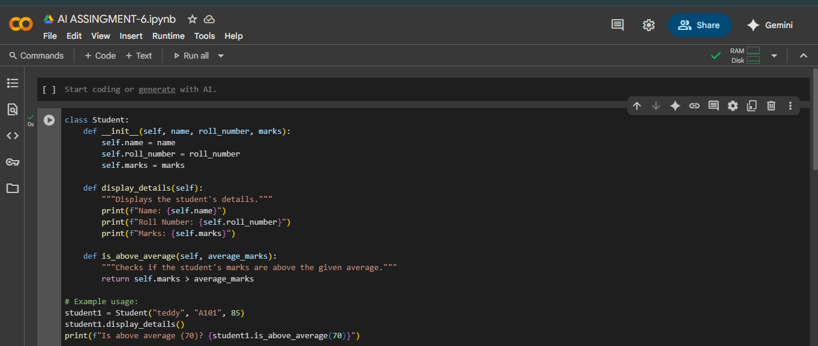

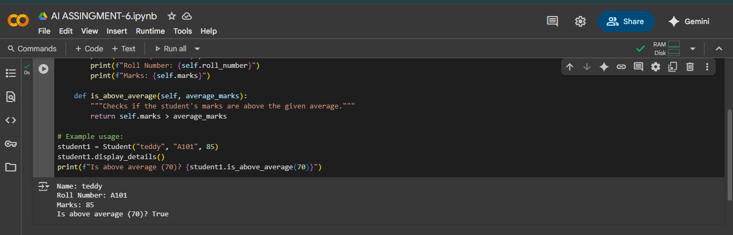

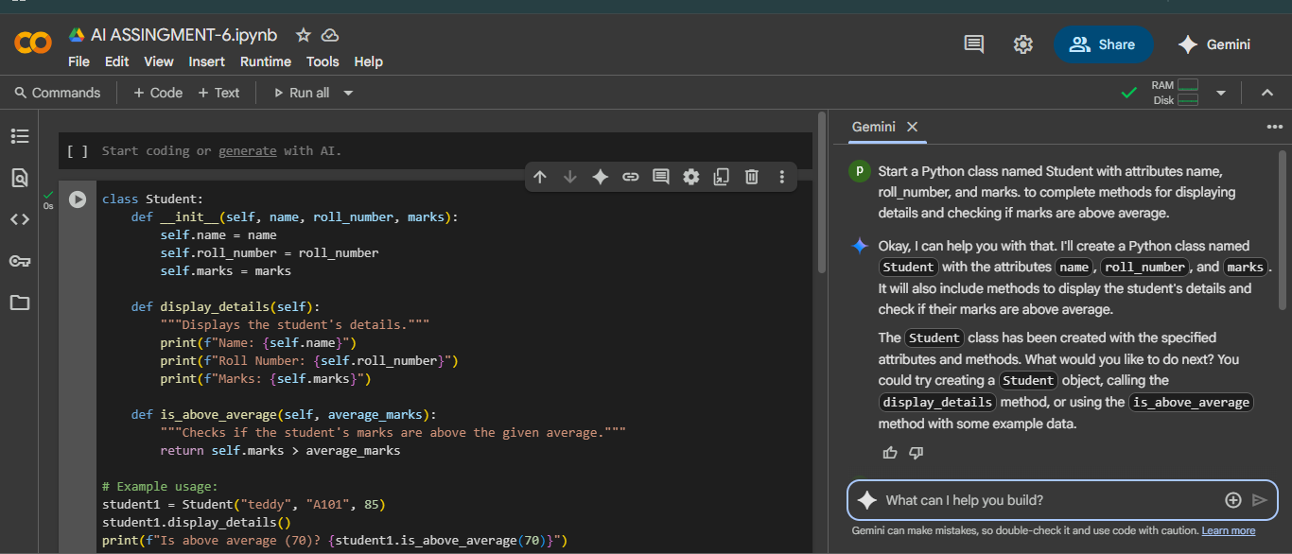

Task Description #2:
• Write the first two lines of a for loop to iterate through a list of numbers. Use a comment prompt to let Copilot suggest how to calculate and print the square of even numbers only
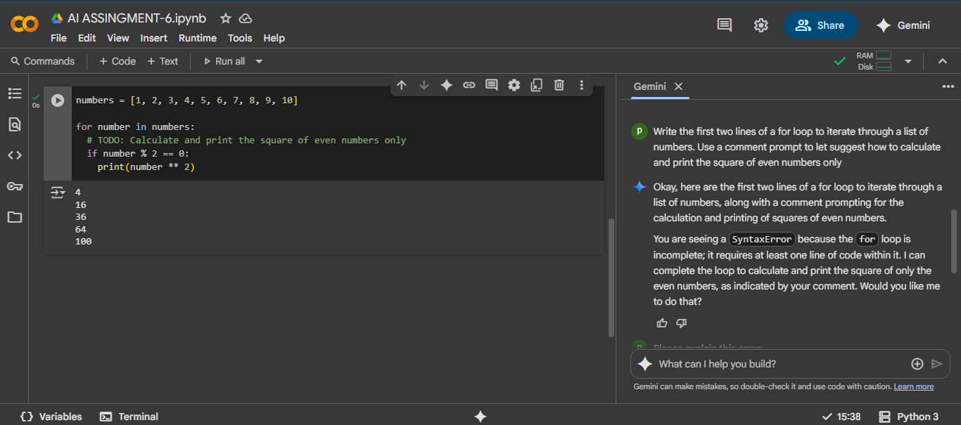
EXPLANITION:

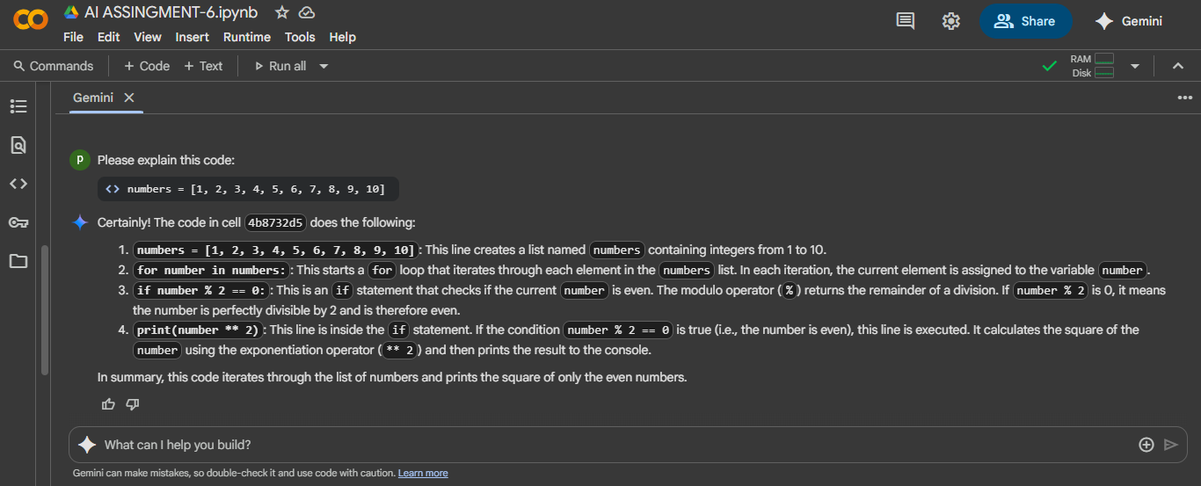

Task Description #3:
• Create a class called BankAccount with attributes account_holder and balance. Use Copilot to complete methods for deposit(), withdraw(), and check for insufficient balance.
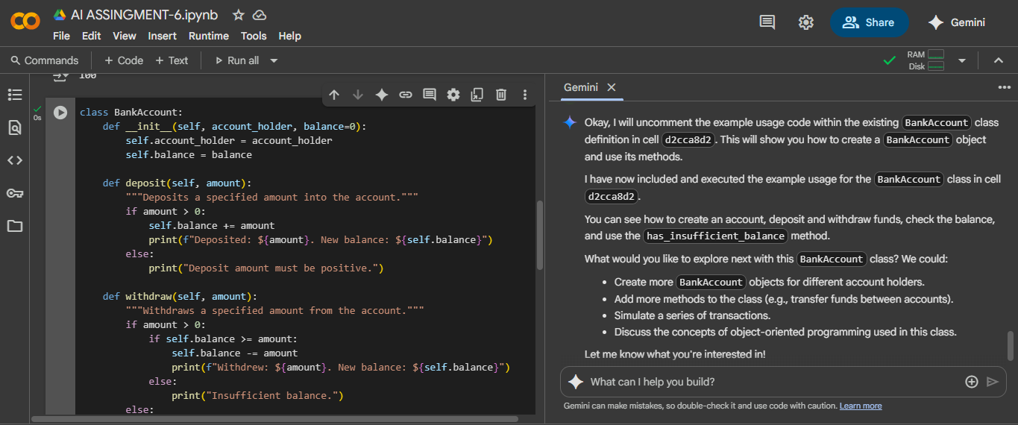
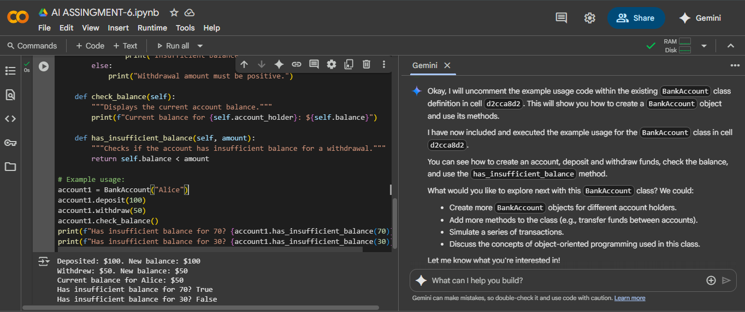
EXPLANITION:

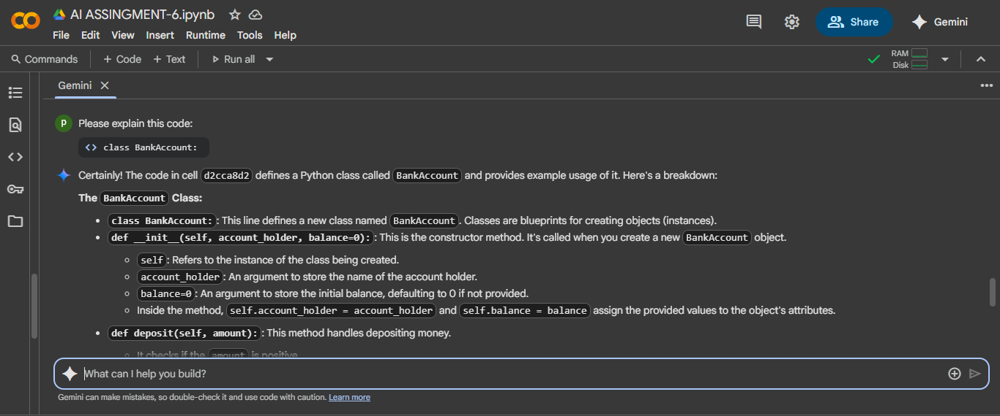
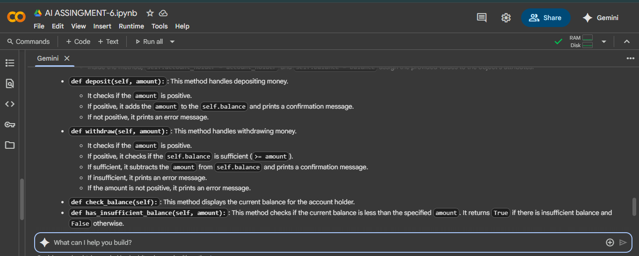

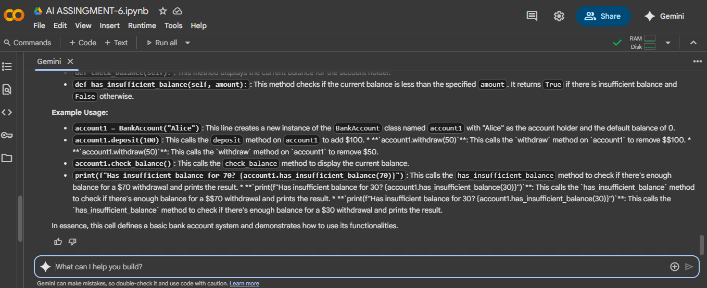

Task Description #4:
• Define a list of student dictionaries with keys name and score. Ask Copilot to write a while loop to print the names of students who scored more than 75.
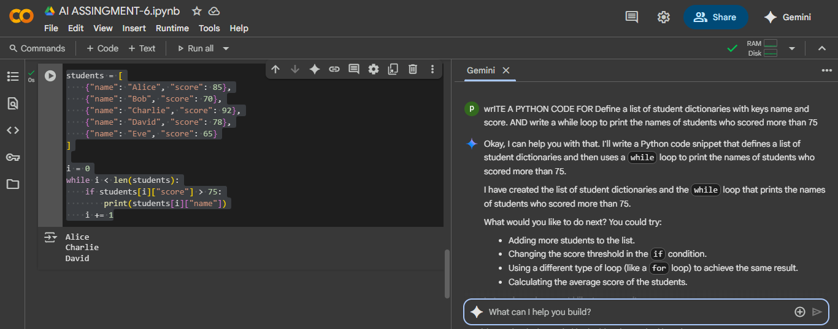
EXPLANITION:
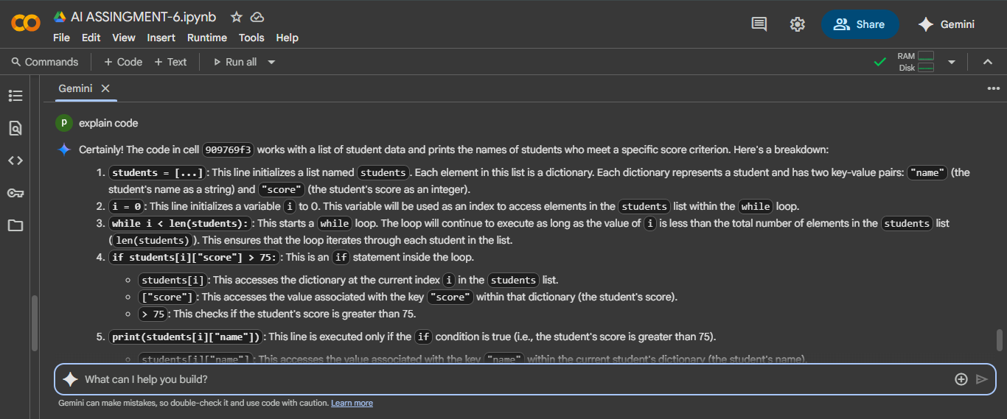

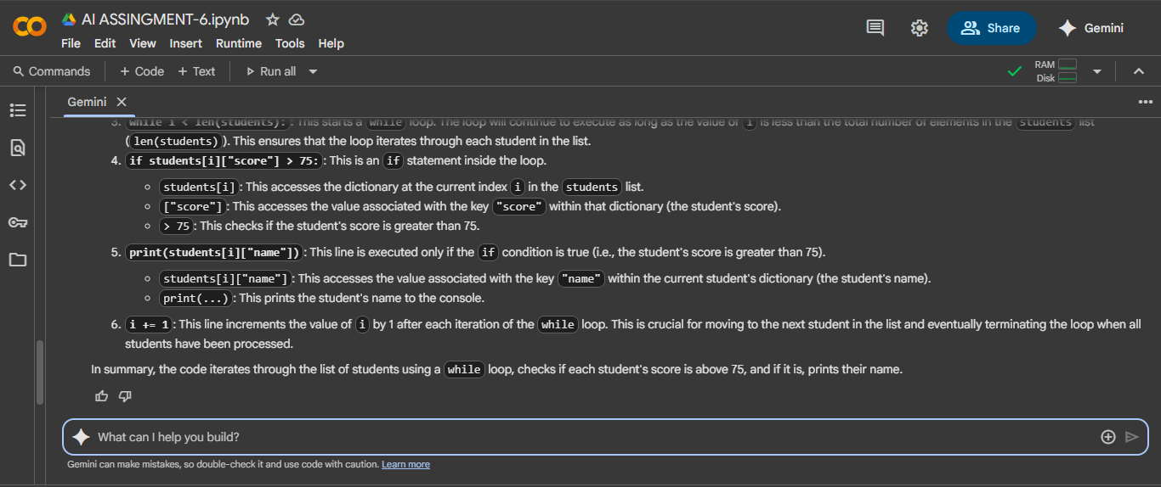

Task Description #5:
• Begin writing a class ShoppingCart with an empty items list. Prompt Copilot to generate methods to add_item, remove_item, and use a loop to calculate the total bill using conditional discounts.

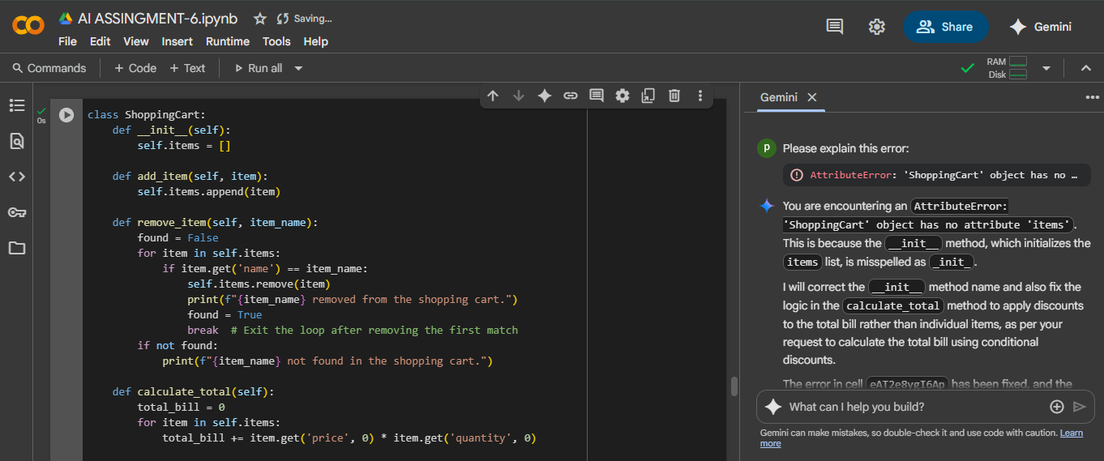
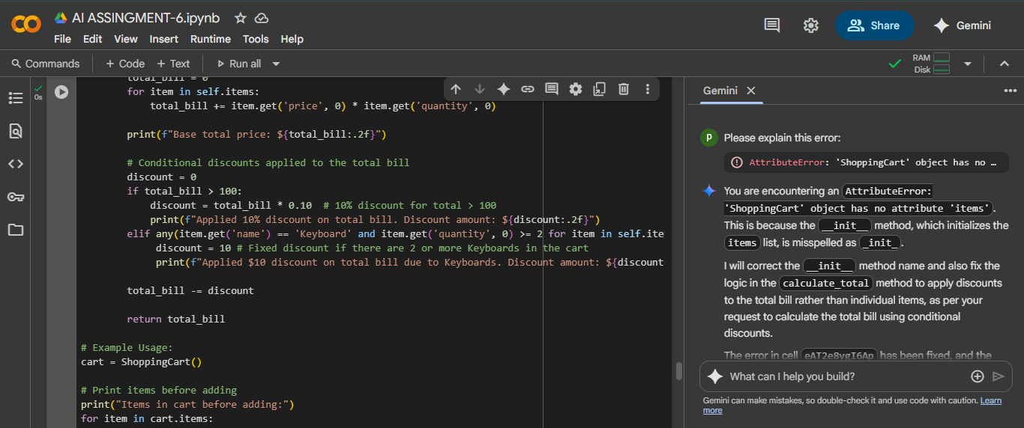

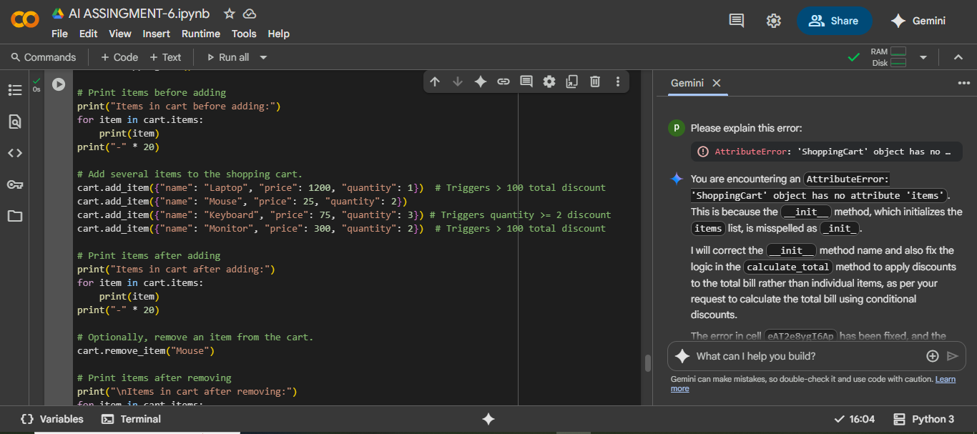

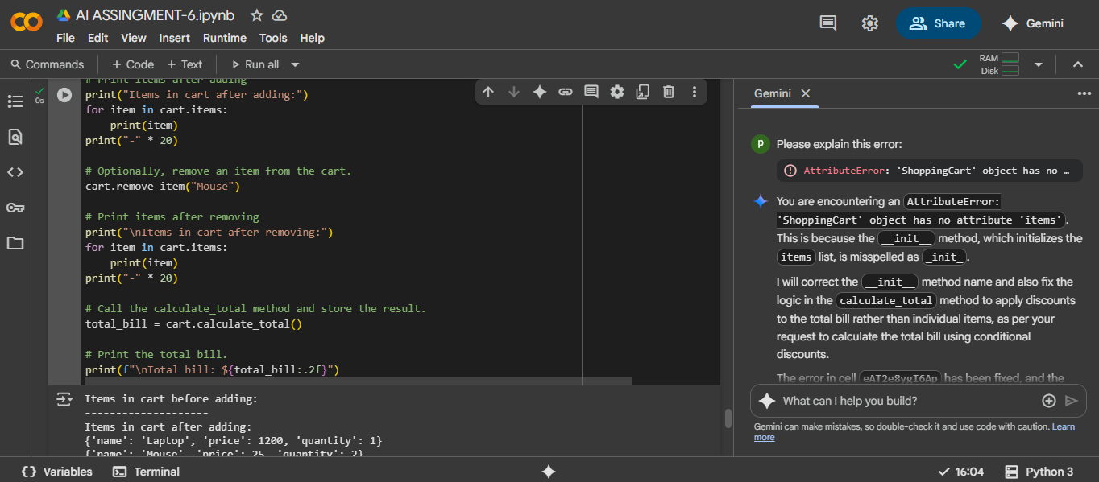
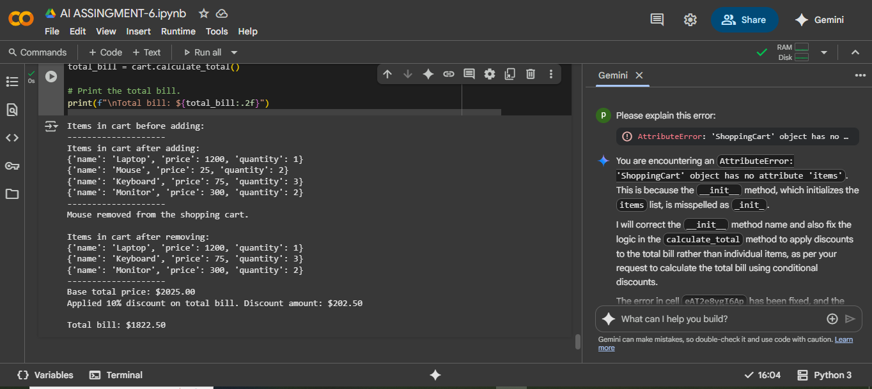
EXPLANITION:
